Name _______________________ Class_______________
Click here for workbook
The Federation of the Commonwealth of Australia

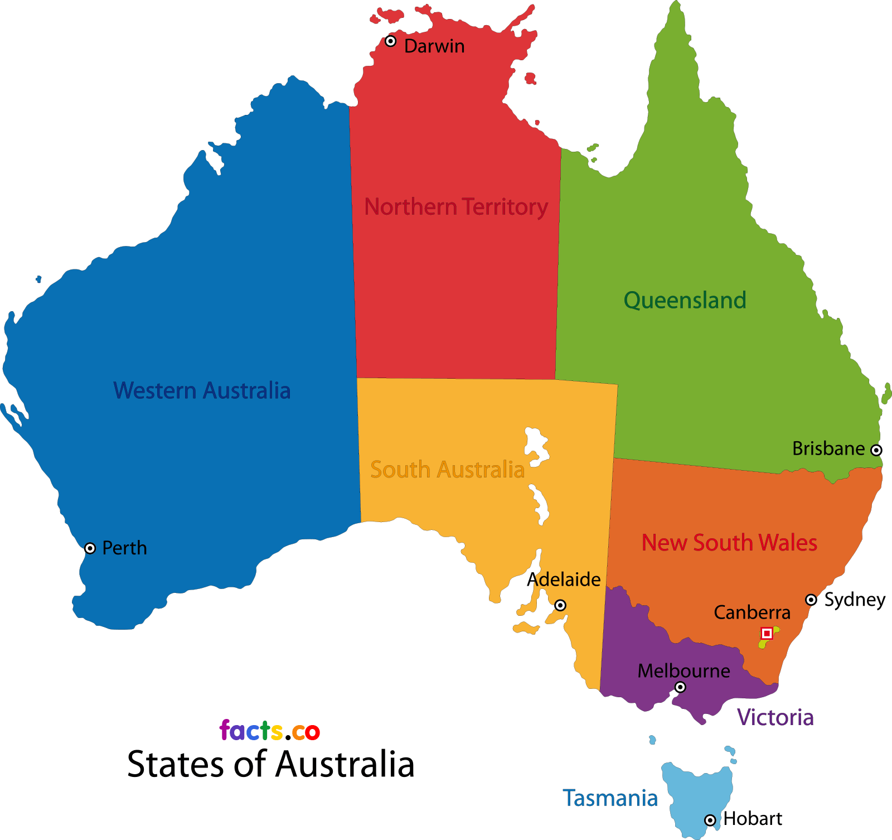
Name ___________________________________ Class_______________________
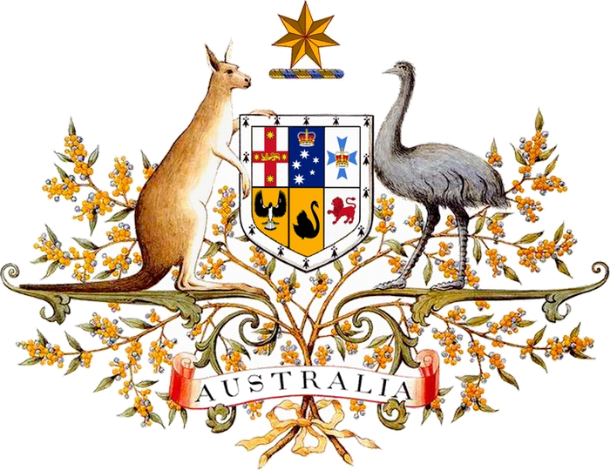
Advance Australia Fair

Australians all let us rejoice
For we are young and free
We've golden soil and wealth for toil
Our home is girt by sea
Our land abounds in nature's gifts
Of beauty rich and rare
In history's page, let every stage
Advance Australia Fair
In joyful strains then let us sing
Advance Australia Fair

Beneath our radiant Southern Cross
We'll toil with hearts and hands
To make this Commonwealth of ours
renowned of all the lands
For those who've come across the seas
We've boundless plains to share
With courage let us all combine
To Advance Australia Fair
In joyful strains then let us sing
Advance Australia Fair.
Open the Coat of arms hyperlink and complete the following;-
- Who was the author and when was Advance Australia Fair written.___________________________________________________________________________________________________________________________________
- What was the anthem before Advance Australia Fair?
___________________________________________________________________________
- Why do you think the original anthem was considered inappropriate?
_________________________________________________________________________________________________________________________________________________________________________________________________________________________________
- When was Advance Australia Fair made the National Anthem?___________________
- Read the original lyrics here ; Why do you think they were removed in the 1980’s
_________________________________________________________________________________________________________________________________________________________________________________________________________________________________________________________________________________________________________________________________________________________
(Albion + England Erin = Ireland Britannia + UK)
- The word “fair” has two distinct meanings as an adjective in English write down both
____________________________________________________________________________________________________________________________________________________________________________________________________________________________________________________________________________________
_____________________________________________________________________
- Which one would an “Australian” think would be correct ;-
- In 1878____________________________________________________________
- In 1984____________________________________________________________

Sydney Olympics 2001
Cathy Freeman wins Gold in the 400 metre sprint
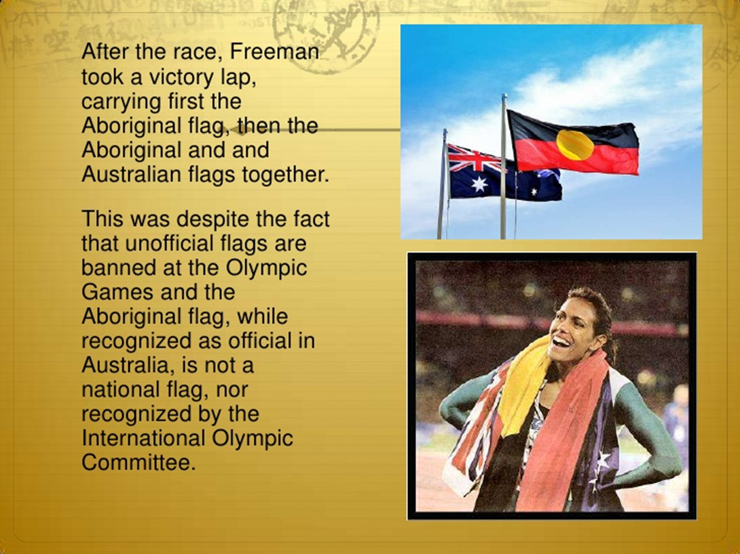
On the 1st of January 1901 the six British colonies;- New South Wales, Victoria, Queensland, Tasmania, South Australia and Western Australia joined together to become a new country, The Commonwealth of Australia. It had taken 16 years for the English speaking, culturally British, self- governing states to become a nation. There had been no freedom struggle, no war of independence just meetings, more meetings and encouragement from London.
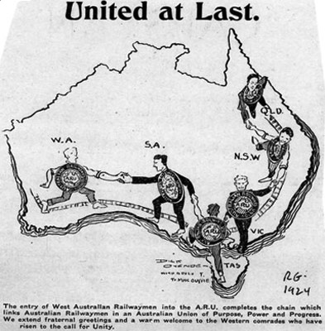 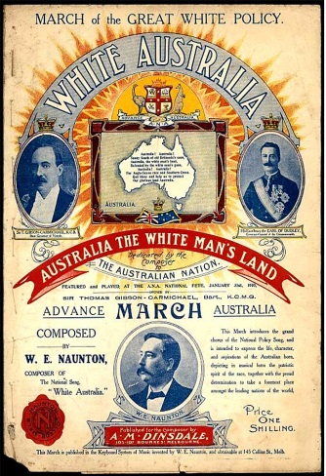 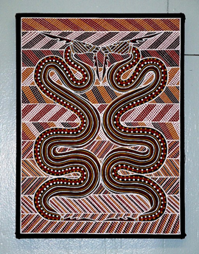 extra links
Click on the Cathy Freeman image and watch the video.
- Describe what is happening in the video Where when what???
______________________________________________________
______________________________________________________
____________________________________________________________________________________________________________

- Explain why she is wearing two flags. _______________________
____________________________________________________________________________________________________________
____________________________________________________________________________________________________________

- What do you think about Cathy Freeman wearing two flags at the Sydney Olympics in 2000?
__________________________________________________________________________________________________________________________________________________________________
- What and when was Federation? ____________________________________________________________________________________________________________________________________________________________________________________________________________________

- What process brought about Federation?________________
________________________________________________________________________________________________________________________________________________________________________________________________________________________
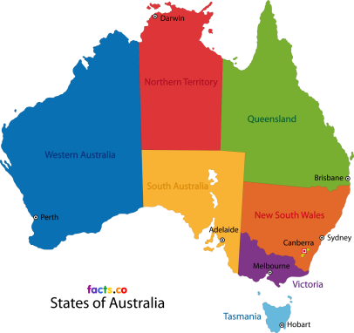 click on images for video 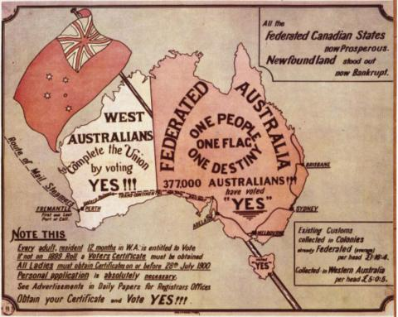

- How was travelling between the states difficult before 1901?
__________________________________________________________________________________________________________________________________________________________________
- If Australia wasn’t a country before 1901 what was it?
__________________________________________________________________________________________________________________________________________________________________
- Who was the person who pushed hard for federation and where did he come from?________________________________
____________________________________________________________________________________________________________
- What did the states manage to create in 1891?
____________________________________________________________________________________________________________
- What is a Constitution? _______________________________________________________________________________________________________________________________________________________________
- What does the Australian Constitution do? ____________________________________________________________________________________________________________________________________________________________________________________________________________________
- What was different about South Australia in 1900?
____________________________________________________________________________________________________________

- Which state did not agree to join the Federation in 1899?
______________________________________________________
- Where and when was the Commonwealth of Australia proclaimed? __________________________________________________________________________________________________________
- What powers did the states keep?
__________________________________________________________________________________________________________________________________________________________________
- What aspects of government went to the Commonwealth?
__________________________________________________________________________________________________________________________________________________________________
- Why were Aboriginal and Torres Strait Islanders unhappy with the Constitution? ___________________________________
______________________________________________________
______________________________________________________

What did you like about this unit?______________________________
__________________________________________________________
What did you dislike about this unit?____________________________
__________________________________________________________
Imagine you're on a train, travelling for hours across the vast Australian continent and part way through your journey this happens.
Back in the late 1800s, making a trip between Australian colonies was a bit like travelling to a different country. You could be stopped at the border by Immigration and searched. In fact if you were travelling between, say, New South Wales and Queensland, you would have had to change trains because the rails were different sizes.
Australia wasn't a country; it was just the name of a continent divided into six very separate British colonies. They had different leaders and different laws. They even had their own armies!:But there were some people pushing to change that. One was Henry Parkes, five times Premier of New South Wales.
In 1889, he made a famous speech in the town of Tenterfield about Federation - the push to unite the colonies as a single country. It wasn't the best speech ever, by all account, but it made an impact. Parkes convinced the leaders of the colonies to get together and talk about Federation. Some came from New Zealand. It was a British colony too and it could have joined the new country. After much negotiating, in 1891, the delegates drew up a draft constitution for the Commonwealth of Australia. But the idea didn't take off. It wasn't a good time for the colonies. The economy wasn't doing well, plus there was a feeling that the draft constitution wasn’t democratic enough, that it didn’t give ordinary peoples enough of a say.
Time went on and the colonies kept changing. Many kept fighting for the cause of Federation, like Alfred Deakin. He was part of a new generation, born and bred in Australia, who thought the continent should be a united country.
Eventually, he helped to convince the colonies to give it another shot. This time people got to vote for representatives who'd help to draw up a new constitution. There was a lot of arguing. The bigger, richer states were worried that they'd have to share money with the poorer ones and the small states worried they wouldn't have a say in decisions. South Australia had recently given women the right to vote and it wanted the whole country to have that right. Then there was the issue of where the nation's capital should be.
New Zealand had decided to stay out of it and Western Australia wasn't too keen on Federation either, but eventually, a new constitution was drawn up and most colonies let their people vote on whether or not they wanted in. In 1899, all of the colonies, except Western Australia, said yes. Australia was about to become a nation.
Western Australia did agree to join a year later, but the constitution had already been written and agreed to by the Queen. That's why you can still see a line in here, saying WA gets to be a part of the Commonwealth if 'Her Majesty is satisfied that the people of Western Australia have agreed thereto'.
In 1901, in Sydney's Centennial Park the Commonwealth of Australia was proclaimed a Federation with six states. The states would keep a lot of their law making and tax collecting powers, while the federal government would run things like defence and immigration. The first Prime Minister was Edmund Barton, who'd helped to write the new constitution. Not everyone benefited from Federation. Aboriginal and Torres Strait Islander people weren't included in the constitution, and the new government made it harder for people who weren't European to immigrate to Australia. But it was a major point in Australia's history and the first step towards the country we know today.

